Girls and Computing:
Female participation in computing in Schools
Dr Jason Zagami
Griffith University, Australia
Dr Marie Boden
University of Queensland, Australia
Dr Therese Keane
Swinburne University of Technology
Bronwyn Moreton
President of Robocup Jnr NSW, Australia
Karsten Schulz
Digital Careers, Australia

Computer education, with a focus on Computer Science, has become a core subject in the Australian Curriculum and the focus of national innovation initiatives. Equal participation by girls, however, remains unlikely based on their engagement with computing in recent decades. In seeking to understand why this may be the case, a Delphi consensus process was conducted using a wide range of experts from industry and academia to explore existing research and interventions, recommending four key approaches: engaging girls in the Digital Technologies curriculum; addressing parental preconceptions and influences; providing positive role models and mentors; and supporting code clubs for girls. Unfortunately, all of these approaches have been widely implemented, and while individually successful at the scale of their implementation, have failed to systemically improve female participation in computing. The only discernable difference between initiatives to improve female participation in computing and the successful approaches in other fields such as science, has been the availability of a compulsory developmental curriculum beginning from the start of school, and it is this that may provide a scaffold that sustains female engagement over critical periods such as adolescence, when participation in computing begins to dramatically decline.

Introduction
Computing occupations are predicted to make up two thirds of all new jobs in STEM (Science, Technology, Engineering & Mathematics) related fields (Bureau of Labor Statistics Employment Projections, 2015; elaborated by Code.Org, 2015) and Computer Science has been identified as an essential subject for Australian students (Aynsley, 2015; Spencer, 2015; Shorton, 2015; Turnbull, 2014) to the extent that in 2015 it was incorporated into the compulsory school curriculum (Pyne, 2015). But will all Australian children have equal opportunities to take advantage of these opportunities?

While the numbers of women participating in many STEM areas has been steadily increasing, and in some areas achieving parity, the number of women participating in Computer Science has continued to steadily decrease. US workforce statistics show a peak of almost 40% in the mid 80’s, to less than 30% in 1995, and less than 20% in 2015 (National Science Foundation, 2015), while the US National Science Board (2012) reported female participation in Computer Science declining to 18% in 2012 from a 37% peak in the mid 80’s. While in Australia, only 2.8% of girls compared to 16.3% of boys contemplate pursuing careers in engineering or computing (OECD, 2015), just17% female participation.

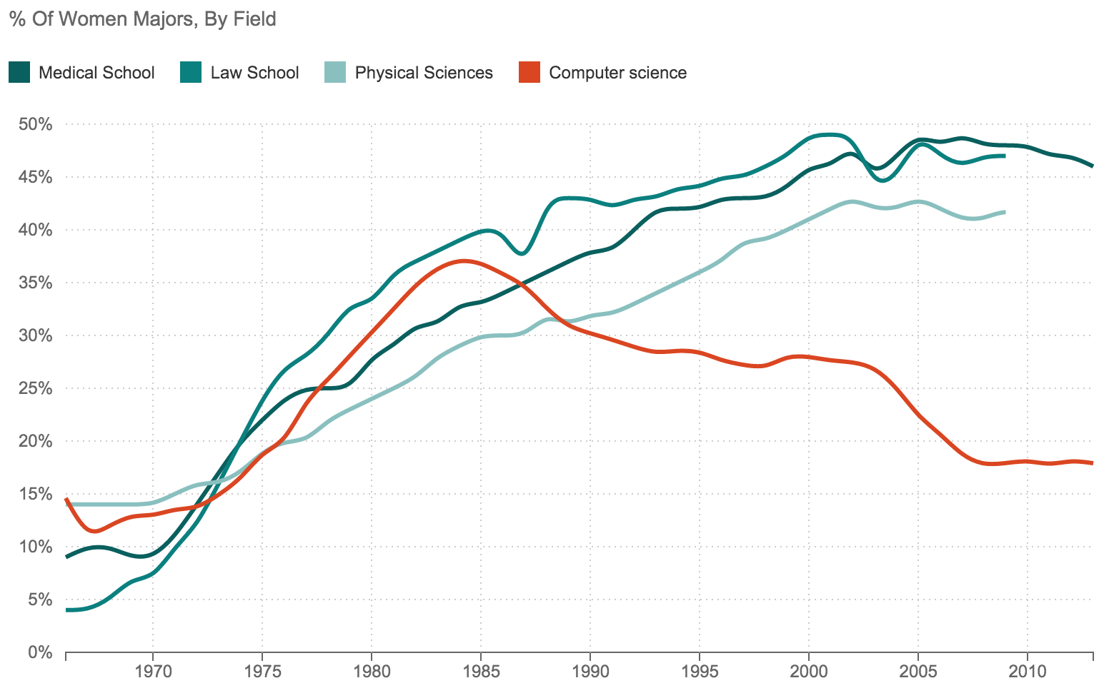
Figure 1. Participation of Women by Field (NPR, 2014).

A broad spectrum of strategies has been used to improve female participation in many fields, with considerable success in mathematics and science education (Brotman & Moore, 2008). Computer Science education however remains intransigent, and while substantial effort has been put into intervention programs and a significant body of research conducted to ascertain the effectiveness of these interventions, they have not resulted in systemic improvements in participation rates. Female disengagement with Computer Science begins to decrease at the commencement of high school, with female participation in extra curricula activities showing a dramatic decrease from parity in primary school to 20% by the end of high school (Bebras Participation Rates, K. Shultz, personal communication, December 3, 2015).
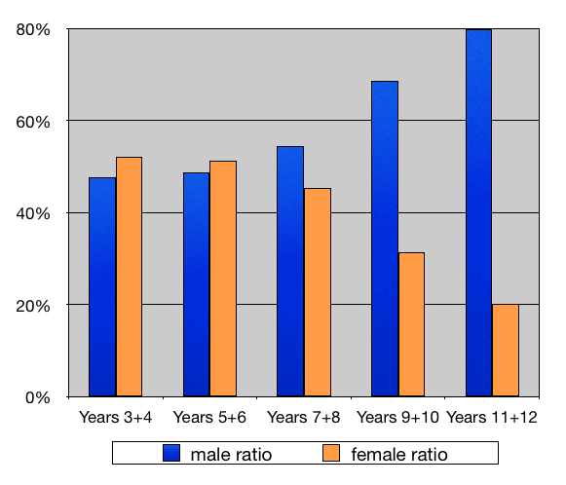
Figure 2. Participation in the Bebras Computing Challenge by gender (Bebras Participation Rates, K. Shultz, personal communication, December 3, 2015).

Research literature

To understand the body of research on female participation in computing, the research team examined over a hundred Australian and international research publications, with this research categorised into three primary factors: Essentialist, Social-cultural and Structural (Osunde, Windall, Bacon, & Mackinnon, 2014). Essentialist factors related to disparity caused by inherent differences between males and females such as mathematical competence and computational thinking ability; Socio-cultural factors suggest that the differences are caused by external (e.g. stereotyping) and internal (e.g. self-expectation) factors which influence the development of males and females; and Structural factors suggest that disparities are caused by the nature of institutions (home, education and industry) such that they limit opportunities for girls to increase in representation without structured intervention.

Ten key articles were then selected by use of a modified Delphi process, and used to inform participants in later stages of the project. Nine articles focused on Socio-cultural factors, one article focused on Structural factors, and interestingly, no key article was selected that focused on Essentialist factors. This emphasis on Socio-cultural factors, with gender differences caused primarily by self-confidence and motivation, and identity related stereotypes, was strongly evident in the selected research literature. This may reflect the relative emphasis on intervention programs, around which most research was framed, with attempts to address Socio-cultural factors, and the relative difficulties in interventions that address Essentialist and Structural factors. It may also indicate a gap in the body of research, with researcher preferences on Socio-cultural factors dominating the discourse, or that researchers have intuitively framed their research towards Socio-cultural factors as the most significant factors in influencing female participation in computing.

Of the nine socio-cultural articles, five focused on category membership stereotypes (Cheryan, Master, & Meltzoff, 2015; Pechtelidis, Kosma, & Chronaki, 2015; Yansen & Zukerfeld, 2014; Lang, 2012) and strategies to negate or mitigate stereotypes. Three articles explored social learning (Pechtelidis, Kosma, & Chronaki, 2015; Yansen & Zukerfeld, 2014; Christoph, Goldhammer, Zylka, & Hartig, 2015) as an effective strategy to engage female students with Computer Science, one article addressed Encouragement, Role Models /Mentoring, Gender Grouping, Educational Policy Reform, and Educational Games (Trauth, Quesenberry, & Morgan, 2004), two articles addressed Encouragement, Role Models/Mentoring, and Awareness Raising (Nelson, 2014, Moakler & Kim, 2014), and a final article defied categorisation (Gras-Velazquez, Joyce, & Debry, 2009) on why girls are not attracted to ICT studies and careers. The only non Socio-cultural factor paper, focused on Structural factors (Google, 2014) addressing issues of Student Encouragement and Educational Policy Reform with four key influencing factors identified as:

- Social Encouragement: Positive reinforcement of Computer Science pursuits from family and peers.

- Self-Perception: An interest in puzzles and problem solving and a belief that those skills can be translated to a successful career.

- Academic Exposure: The availability of, and opportunity to participate in, structured (e.g., graded studies) and unstructured (e.g., after-school programs) Computer Science coursework.

- Career Perception: The familiarity with, and perception of, Computer Science as a career with diverse applications and a broad potential for positive societal impact.

Methodology

The project team was brought together in 2015 from across Australia and included academics, professional association leaders, and female participation initiative leaders.

A qualitative, participatory action research process used a modified Delphi method for consensus analysis of issues related to female participation in Computer Science, and was implemented over a 5 month period, in five phases:

- Review of existing research by the research team with consensus developed on a set of key articles and websites that would inform the research process and public participants in further stages;

- Contribution from the public of ideas and problems related to why girls do not participate fully in computing at school;

- Refinement of ideas where groups are assigned to selected idea’s and supported by a research team mentor to discuss and develop the idea into potential solutions;

- Feedback sought from a range of groups and organisations on the selected ideas; and

- Analysis of results from the research and presentation of a report to Digital Careers.

Findings

The research developed a consensus of views, with participation from a wide range of individuals and interest groups including professional associations, female participation initiative groups, academics, IT companies, teachers, and students. The resulting views of suitable approaches to improving female participation in K-12 Computer Science have been presented in summary, categorised by factors (Osunde, Windall, Bacon, & Mackinnon, 2014), and four specific cases expanded to provide in depth approaches to improving female participation in K-12 Computer Science:

- Engaging girls in the Digital Technologies Curriculum;
- Parental preconceptions and influences;
- Role Models and Mentors; and
- Code clubs for girls.

Contributions from the modified Delphi process identified 12 strategies likely to improve female participation in K-12 Computer Science.

Strategy | Focus | Category | Solution Types
Short Poppy Syndrome | Naive teacher perceptions of talent in Computing are influencing female self efficacy in computing, a stronger focus on the development of higher order thinking skills in primary schools through Computer Science may build student resilience and challenge teacher perceptions. | Social-cultural factors | Stereotypes (category membership), Awareness raising, Educational policy reform.
Evaluating  interventions | Evaluation of programs to engage young people in Computer Science are not well developed and potentially gender biased, the construction of a conceptual framework to evaluate intervention programs could assist in improving them. | Social-cultural factors | The construction of a conceptual framework.
10 and over | Early intervention is needed to engage young people with technology before the age of 10, and especially girls, with the support of specialist primary Computer Science teachers. | Social-cultural | Encouragement, Role models / mentoring, Specialist teachers, Gender grouping, Educational policy reform.
CodeXX Programming for Girls | Girls sometimes find it difficult to engage equally in traditionally male dominated subjects such as computing. Courses for girls only that take advantage of preferences for non competitive and social learning opportunities may improve female participation. | Social-cultural factors | Encouragement, Gender grouping, Social Learning (preference to learn in groups), Educational games.
Let’s ask the girls! | Research into gender issues is often focused on a wide range of factors, drawn from gender studies and other fields of academic endeavour, without specifically finding out what girls themselves want. Conducting research into the views of Australian girls at variously age levels is a significant part of research into female participation. | Social-cultural and Structural factors | An online questionnaire surveying high school and university girls about their thinking around technology (ICT)
WSTEM | Mentoring programs for girls studying Computer Science can strengthen female confidence around computing, provide networks and foster a community of female students in STEM. | Structural factors | Encouragement, Gender grouping, Role models / mentoring
Prose for programming | Incorporating activities such as written or spoken prose and lyrics into the teaching of Computer Science may engage female students by providing them with a foundation in an area of strength and interest. | Essentialist factors | Gender grouping, Social Learning
Girls Programming Networks | Networking opportunities are needed to provide girls with interesting and challenging activities, in fun and positive environments. | Social-cultural factors | Encouragement, Role models / mentoring, Gender grouping
Improving the curriculum in schools to engage girls | This idea or challenge is “Current school IT curricula does not inspire or interest girls this is a major reason why girls do not go on to study IT further” | social-cultural and structural | Stereotypes (category membership), Role models / mentoring, Social Learning (preference to learn in groups), Educational policy reform.
MOBEEAS Role Models and Mentors | To encourage female participation in computing at school by facilitating contact with young enthusiastic and capable role models. | Structural factors | Encouragement, Role models / mentoring, and Awareness raising.
Improving the curriculum in schools to engage girls | Computer science education resources may not be supportive of female student engagement and learning of the Digital Technologies curriculum | Social-cultural and structural | Stereotypes (category membership), Role models / mentoring, Social Learning (preference to learn in groups), Educational policy reform.
Parental preconception and influences | Parents are often not aware of the careers available in Computer Science and strategies available to improve understanding and address misconceptions. | Social-cultural | Encouragement, Role models / mentoring, and Awareness raising.

From the 12 strategies suggested from the public Delphi process, and in some cases an amalgamation of suggested strategies, the four most promising strategies were selected again from a Delphi consensus and explored in detail by focus groups drawn from academic, industry and professional association groups over a two month period:

- Engaging girls in the Digital Technologies Curriculum;
- Parental preconceptions and influences;
- Role Models and Mentors; and
- Code clubs for girls.

Strategy 1. Engaging girls in the Digital Technologies curriculum

Problem
Some existing Computer Science education resources may not be supportive of female student engagement and learning of the Digital Technologies curriculum.

Aim
The aim of this strategy is to ensure that the Digital Technologies curriculum supports the interests and learning of female students.

Approach
The curation and development of gender inclusive or neutral Computer Science activities to support the teaching of the Digital Technologies curriculum. Research is needed to map existing resources with respect to the curriculum and to identify appropriate resources and pedagogical approaches, particularly in addressing potential essentialist factors related to gendered brain development, and structural factors related to contextual choices made for computer education activities.

Strategy 2. Parental preconceptions and influences

Problem
Parents and relatives of young girls are often not aware of what careers and professions the study of Computer Science can lead to for their daughters, and subsequently many parents do not see computing or engineering as a possible future profession for their daughters.

Aim
To inform parents about the wide variety of computing professions available and the possibilities for women in computing related careers and to identify perceptions among parents and relatives and address misconceptions by organising workshops and engagement activities that include parents, relatives and girls.

Approach
Workshops in schools and articles in parent magazines and school newsletters featuring female university computing students who promote computer studies and highlight careers pathways.

Strategy 3. Role Models and Mentors
Problem
Exposure to inspirational role models play an important part in the career selection process of young woman but access to female role models in computing related careers is often limited.

Aim
To ensure that female students have opportunities to develop role models that are supportive of study and career opportunities in computing, and mentors that can prove direct support.

Approach
To create opportunities for accomplished academics, professionals and university students to mentor school-aged students via well-orchestrated self-perpetuating mentor programs. To support mentorships, databases of mentors and structures to manage the assignment and support of mentors with schools and individual students may be required, as well as structures to support schools, teachers and students with the mentoring process.

Strategy 4. Code clubs for girls

Problem
Many existing code club initiatives have predominantly male participation and girls are sometime more engaged with programs that are differentiated and designed to cater specifically for female interests.

Aim
To provide code club opportunities for girls that cater for their interests and enable girls to socialise with other girls interested in Computer Science. This will give girls exposure to Computer Science and encourage them to consider computing studies and careers.

Approach
To support code club initiatives, particularly in early primary and late secondary school grades, when differentiated programs are less impacted by developmental social pressure.

Conclusions

While the four specific strategies identified by the Delphi process were selected as those most likely to be effective approaches to addressing low participation of females in K-12 Computer Science in the current Australian context, an important caveat to this identification was a growing understanding that no one approach is sufficient, and that a range of strategies is likely necessary to address female underrepresentation, with the interactions between strategies, reinforcing and generating greater influence than any one individual approach.

It also became clear from examination of existing research, that all of the strategies identified had been implemented many times in the past, individually and in combinations, and while most initiatives reported positive impact in described research, systemically they have not been sufficient, either through scale of implementation or long term effect, to address the overall decline in female participation in Computer Science.

Three key factors have emerged from this examination:

- There does not appear to be any fundamental difference between approaches to improve female participation in computing and those used in similar disciplines such as science and mathematics.

- Engineering as a discipline has similar low female participation to computing with similar interventions and initiatives to address the participation rate.

- While similar approaches to improve female participation in other fields have been successful, computing (and engineering) have not show improvements, with computing participation continuing to decline.

The question thus arose, what factors are different between computing (and engineering) and fields that have shown sustained success in engaging females. Socio-cultural factors were in the main similar, as were essentialist factors. Most structural factors were similar, but a key structural factor at variance was how the discipline is treated in school curricula.

Mathematics and science education have a strong mandatory curriculum framework stretching from school entry to the end of compulsory schooling. This has provided a scaffold upon which intervention initiatives can be supported and benefits sustained. Computing (and engineering) have lacked a developmental curriculum, with uncoordinated and one off courses, if any, included in the curriculum.

Without a strong curriculum framework in schools, initiatives and interventions to address female participation in computing have usually occurred extra curricula, this in itself may have contributed to a negative impression of computing, particularly in early adolescence when peer acceptance is a priority, and initiatives that differentiate students from the norm may be counterproductive, especially at this age in student identity development, and notably is the age at which student engagement with computing begins to decline.

Recommendations

This research suggests that in supporting initiatives to increase female participation in computing:

- a broad range of initiatives continue to be supported, with priority on the four strategies identified; Engaging girls in the Digital Technologies Curriculum; Parental preconceptions and influences; Role Models and Mentors; and Code clubs for girls.

- consideration be given to prioritising initiatives that integrate with the school curriculum, especially the Digital Technologies subject, to normalise and sustain the effects of initiatives; and

- consideration be given to prioritising initiatives that have a sustained progression, building on student participation and sustaining their interest in computing, particularly over the key period of Years 7 - 8 when female participation begins to decline.

With the introduction of a developmental Computer Science discipline within Australian compulsory schooling, the Digital Technologies subject may provide a framework upon which female participation in computing can be addressed. As with participation in Mathematics and Science, addressing the lack of female participation in computer Science will require the sustained efforts of a wide range of programs and initiatives in addition to the new curriculum.
Acknowledgement
Research supported by Digital Careers, Intel, and the Australian Council for Computers in Education
Research data available from http://jzagami.info/wordpress/research/girls-computing/

References

Aynsley, B. (2015, April 14). Equipping kids with digital skills key to future success. The Australian Business Review. Retrieved from http://www.theaustralian.com.au/business/technology/equipping-kids-with-digital-skills-key-to-future-success/story-e6frgb0o-1227302409131

Bureau of Labor Statistics Employment Projections. (2015). Retrieved from http://www.bls.gov/emp/tables.htm

Brotman, J., & Moore, F. (2008). Girls and science: A review of four themes in the science education literature. Journal of research in science teaching, 45(9), 971.

Cheryan, S., Master, A., & Meltzoff, A. (2015). Cultural stereotypes as gatekeepers: increasing girls’ interest in computer science and engineering by diversifying stereotypes. Frontiers in psychology, 6.

Christoph, G., Goldhammer, F., Zylka, J., & Hartig, J. (2015). Adolescents' computer performance: The role of self-concept and motivational aspects. Computers & Education, 81, 1-12.

Code.Org. (2015). Summary of source data for Code.org infographics and stats. Retrieved from https://docs.google.com/document/d/1gySkItxiJn_vwb8HIIKNXqen184mRtzDX12cux0ZgZk/pub

Google. (2014). Women Who Choose Computer Science - What Really Matters. Retrieved November 2, 2015, from http://static.googleusercontent.com/media/www.wenca.cn/en/us/edu/pdf/women-who-choose-what-really.pdf.

Gras-Velazquez, A., Joyce, A., & Debry, M. (2009). Women and ICT: Why are girls still not attracted to ICT studies and careers?. European Schoolnet.

Lang, C. (2012). Sequential attrition of secondary school student interest in IT courses and careers. Information Technology & People, 25(3), 281-299.

Moakler, M., & Kim, M. (2014). College Major Choice in STEM: Revisiting Confidence and Demographic Factors. The Career Development Quarterly, 62(2), 128-142.

National Science Board (2012), Science and Engineering Indicators. Retrieved from http://www.nsf.gov/statistics/seind12/

National Science Foundation. (2015). Retrieved from http://nsf.gov/statistics/2015/nsf15311/digest/theme2.cfm#compsci

Nelson, B. (2014). The data on diversity. Communications of the ACM, 57(11), 86-95.

NPR (2015). When Women Stopped Coding. Retrieved from http://www.npr.org/sections/money/2014/10/21/357629765/when-women-stopped-coding

OECD (2015), The ABC of Gender Equality in Education: Aptitude, Behaviour, Confidence, PISA, OECD Publishing. http://dx.doi.org/10.1787/9789264229945-en

Osunde, J., Windall, G., Bacon, L., & Mackinnon, L. (2014). Female Underrepresentation in Computing Education and Industry - A Survey of Issues and Interventions. International Journal of Advanced Computer Science and Applications, 5(10).

Pechtelidis, Y., Kosma, Y., & Chronaki, A. (2015). Between a rock and a hard place: women and computer technology. Gender and Education, 27(2), 164-182.

Pyne, C. (2015, September 18). A new national curriculum from 2016. [Press release]. Canberra, Australia: AGPS. Retrieved from https://ministers.education.gov.au/pyne/new-national-curriculum-2016

Shorton, B. (2015, May 14). Budget Reply Speech. [Speech]. Canberra, Australia: AGPS. Retrieved from http://www.alp.org.au/budget_reply_speech

Spencer, L. (2015, February 20). Turnbull calls for earlier introduction of coding in schools. ZDNet. Retrieved from http://www.zdnet.com/article/turnbull-calls-for-earlier-introduction-of-coding-in-schools/

Trauth, E. M., Quesenberry, J. L., & Morgan, A. J. (2004). Understanding the underrepresentation of women in IT: toward a theory of individual differences. Proceedings of the 2004 SIGMIS conference on Computer personnel research: Careers, culture, and ethics in a networked environment. ACM.

Turnbull, M. (2014, October 24). The Importance of Tech Education in Our Schools. [Speech]. Canberra, Australia: AGPS. Retrieved from http://www.malcolmturnbull.com.au/media/speech-the-importance-of-tech-education-in-our-schools

Yansen, G., & Zukerfeld, M. (2014). Why Don’t Women Program? Exploring Links between Gender, Technology and Software. Science Technology & Society, 19(3), 305-329.

